**Integrating Source Material**

**Part 1**

***Quote***

Stiglitz (2012) states that, “…there are two ways to become wealthy: to create wealth or to take wealth away from others. The former adds to society. The latter typically subtracts from it, for in the process of taking it away, wealth gets destroyed. A monopolist who overcharges for his products takes away money from those whom he is overcharging and at the same time destroys value. To get his monopoly price, he has to restrict production.”

***Paraphrase***

Creating riches or stealing it from others are the two ways to get affluent. The first improves society. The latter frequently deducts from it because wealth is destroyed when it is taken away. A monopolist who overcharges for his goods deprives his customers of money while simultaneously destroying value. He needs to limit output in order to obtain his monopolistic price (Stiglitz, 2012).

**Part 2**

Visual elements are critical when carrying out research as they represent the details of the research in the easiest way possible for the reader to decipher. The following are some of the ideas that could be helpful in a research paper: The first is the use of graphs. They could be line graphs, bar graphs or pie charts. They are visual representations of numerical data that is represented in the research. For instance when talking about population distribution, bar or line graphs could create visual presentation.

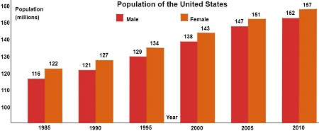

(Example of a bar graph of population)

Another visual element that is necessary to use in research is images. The images are a representation of projects or phenomenon that is being discussed in the research. They create an idea in the mind of the reader about the phenomenon and help the reader have a better understanding of facts and visual reality of what is being discussed

**Reference**

Stigilitz, J. E. (2012). The price of inequality. <https://www.amity.edu/abs/abr/pdf/Vol%2014%20No.2/Book%20Review.pdf>